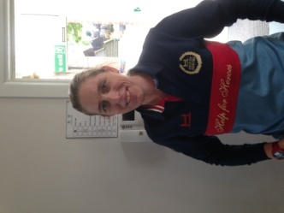

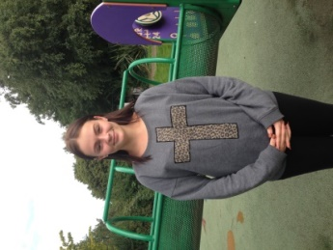


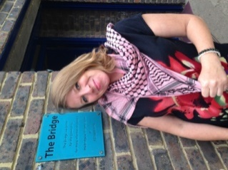
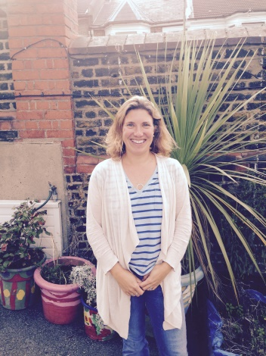

At 5pm every day, we have circle time where we all sit down together. This is a
special time when we all, from reception to year 6, enjoy listening to each other: children do ‘show and tell’, put on a gymnastics display or drama production, bring in their collections of stones, erasers or cards from home, or tell us about their weekend. At the end of circle time, all the children have a chocolate biscuit. We aim to foster a caring and open relationship between all children, parents and playworkers. All reception children have a key worker assigned to them to help them settle in and keep an extra special eye on them. For all our children, we aim to feedback to parents at least once a week at pick up time so you know what your child has been doing at club.

We are very flexible!
We always aim to be as flexible as possible in order to meet the needs of our working parents. For breakfast club or after school club, please text, email or call Holly on 07971 215411 or thehollytreeclub@hotmail.com or hollymorgan2013@hotmail.co.uk at any time prior to the days you require (on the day is fine too!) and subject to space, we will be happy to look after your children for you.
Newsletter: September 2015

Dear parents and carers,

Welcome to the new school year! We are really happy to be back and we have loved hearing what everyone has been up to during their summer holidays! We are very happy to welcome back all our children and to welcome to our club many new faces!

We are privileged to have two sites now for our after school club and we aim to provide the same highly individualised care and attention for your children at both The Bridge and The Bell House.

Our aim is to provide a ‘home from home’ environment where we celebrate every child’s personality; we identify their needs, likes and dislikes and provide a wide range of activities to promote a rich play environment and to help children in their physical and emotional development.
Who we are
We welcome Tracy White to our team: Tracy is a swimming instructor at the Greenwich Centre, SEND governor at Christchurch Primary School and our new manager at The Bell House. Phoebie Grant is doing her apprenticeship with us studying for a NVQ in childcare. She divides her time between The Bridge and The Bell House. We welcome back Lucy and Kalju who co-manage The Bridge as well as Eleanor and Krisztina who are deputy managers at The Bell House. Lucy has a great deal of experience working in educational and play settings specialising in children with additional needs. Kalju has taught English abroad and is training to be a primary school teacher. Eleanor is an English teacher and Krisztina has a Level 2 certificate in Playwork.
Holly
Tracy
Lucy
Kalju
Krisztina
Eleanor
Phoebie

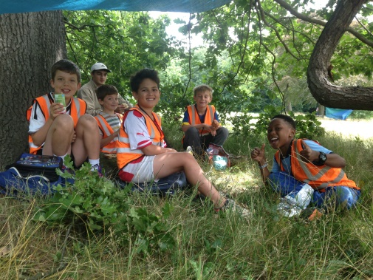
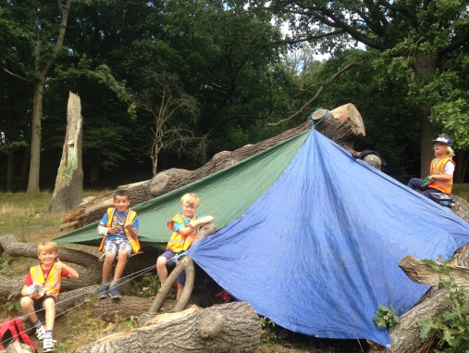
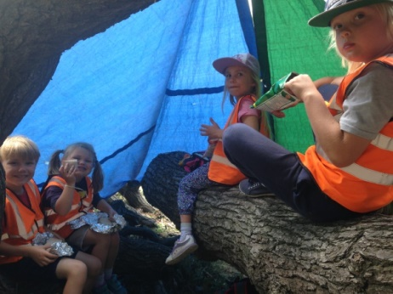
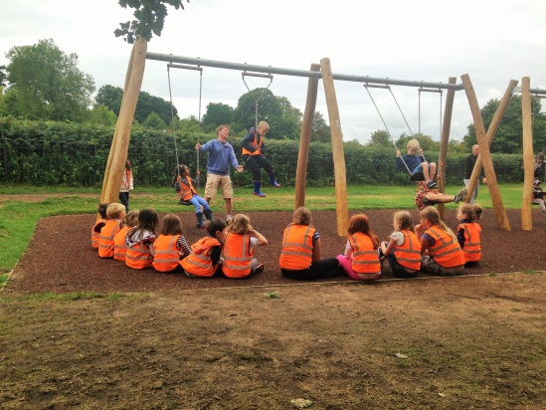
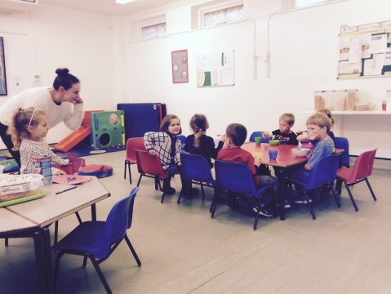
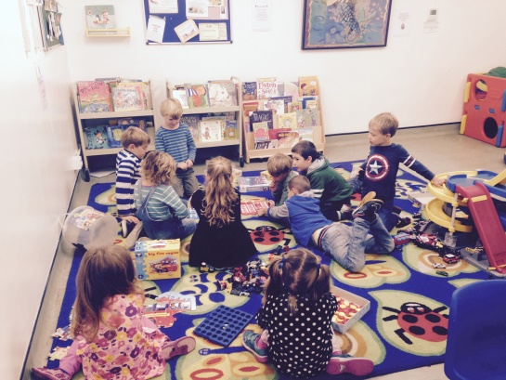
Breakfast club
We now have a breakfast club at The Bridge open Mondays to Fridays from 8am. We provide a range of healthy cereals and toast with various toppings with orange juice and hot chocolate in the winter. We love this time of the day and we enjoy helping the children have a good breakfast and be happy and ready for school. We charge £7 per day with a 10% discount for siblings or 4 or more days booked per week (one discount applies per family).
Summer holiday club
We had a fantastic two weeks at the end of August at our holiday club. We visited lots of local parks, museums and farms. As always, we love going to Ladywell Fields to wade in the stream (we waded really far this year!) and we discovered the Adventure Playground there, a huge wooden structure for the children to play on. The Thames Barrier was great: we took tarpaulins this year: sliding down the slope was such good fun! The children loved searching for bones and pottery on Greenwich ‘beach’. We spoke to some metal detectors on the beach who told us that many of the items we find date from Tudor times. One of them showed us an 18th century coin he had found that day. Two of our favourite days involved building dens in Oxleas Woods and in the woodland area at the top of Greenwich Park. It is lovely to celebrate so many of the play opportunities that Greenwich and the surrounding area offer us. We have children from many local primary schools attending our holiday club and we love to see new friendships develop and blossom as children return each holiday period.
Our playworkers
Thank you to Will, Megan, Sammy and Imani for continuing to create a great play environment and we welcome new playworkers to the team: all A level students studying at local schools with substantial experience looking after children (photos in the next newsletter).

Our new venue: The Bell House
At The Bell House, we have a lovely big and sunny room upstairs where we have a pop up tent, dressing up clothes, table football, lego, building bricks, playmobile castle and pirate islands, puzzles, games, and jigsaws as well as four shelves of books. We have rugs and cushions to make it cosy! Downstairs is where we have messy play with arts and crafts, playdough, biscuit decorating and cornflour. Outside we have a water table, a badminton net, table tennis tables, some very bouncy basketballs and new footballs as well as another tent and lots of other sporting equipment. Being on school grounds mean we can be extremely flexible with regards to pickup times: currently we collect children from extracurricular activities at 4.05pm, 4.25pm, 4.30pm, 5pm and 5.30pm! All the children are escorted to the Bell House and offered our big snack of sandwiches, fresh fruit and vegetables, breadsticks and rice cakes.

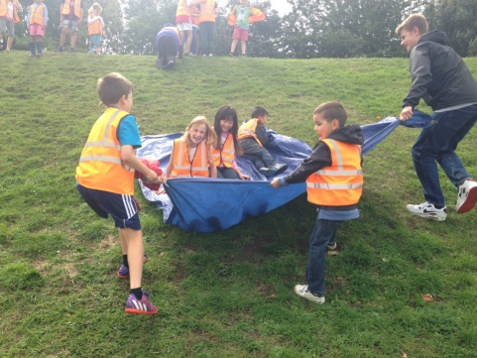
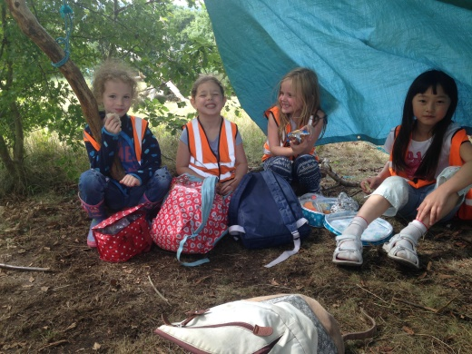
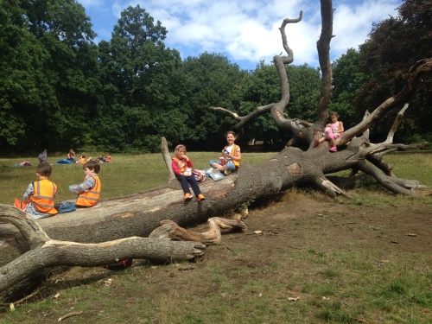
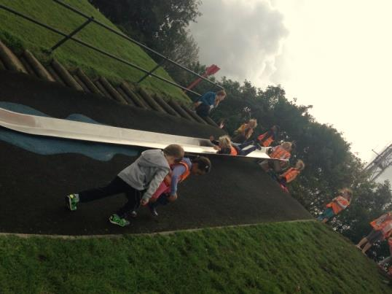
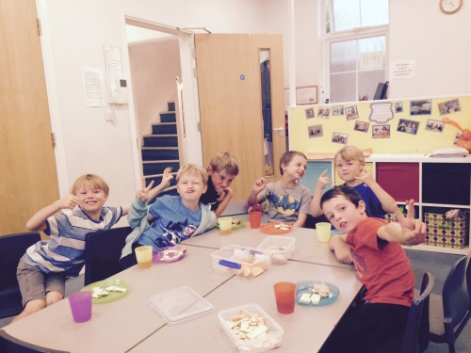
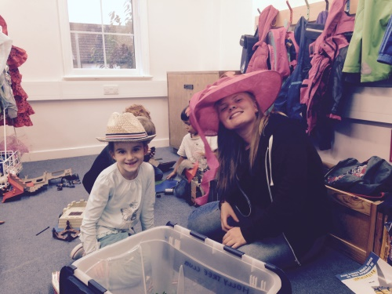
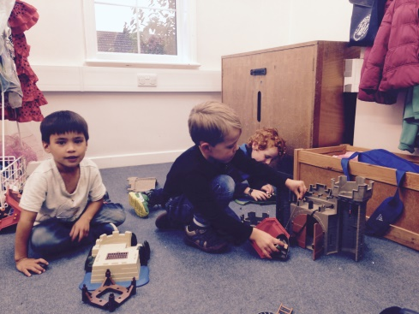
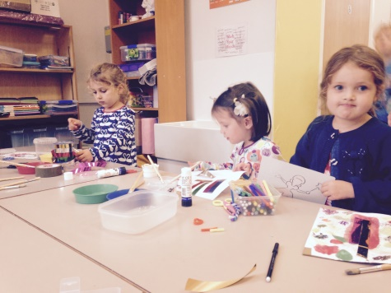
Wishing you a very happy new school year, Holly and the team
07971 215411 thehollytreeclub@hotmail.com hollymorgan2013@hotmail.co.uk
Please have a look at our website www.thehollytreeclub.com (created by Rebecca Jhaveri, Isaac and Sophia’s mum) which provides further details on all that we do and more information on our October holiday club.
Parent feedback
Thank you very much for your questionnaires at the end of last term. It is lovely to read so many compliments about the club! We have taken on board your suggestions: soon we will be introducing a two week snack menu and we will produce a regular newsletter letting you know what we have been up to. We are always very keen to hear what you think of our offering and ways in which we can improve. Please let us know!
October holiday club
We have a four day holiday club coming up in the October half term: Monday 26 to Thursday 29 August. We plan to continue with our successful formula of days out between 9am and 3pm then back at The Bridge for arts and crafts, sports, game and imaginative play until 6pm. The day starts at 8am for breakfast and finishes at 6pm. Again, we are flexible, so if you want to drop off at 9am and pick up at 3pm or other combinations, please get in touch and we’ll do our best to meet your requirements. The cost for the day (regardless of pickup time) from 9am is £30, or from 8am it is £35.
Parent feedback includes:
‘I think the holiday club is great value for money considering the amount of individual attention and interaction the children get, as well as the snacks!’
‘The children have been at a couple of out of school clubs and enjoy this one by far the most’

