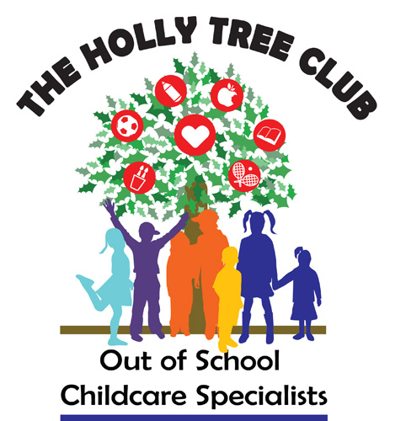
Coronavirus / Covid-19 Agreement
I acknowledge the contagious nature of Coronavirus and that the latest government guidance recommends practising social distancing and a range of other protective measures.
I recognise that The Holly Tree Club has put in place a series of protective measures to reduce the risk of Coronavirus transmission within the setting, but I accept that The Holly Tree Club cannot guarantee that my child will not be exposed to Coronavirus whilst attending the club.
I understand that I must follow the procedures set out by The Holly Tree Club when dropping off and collecting my child from the setting.
We request that, as far as possible, only one parent/carer drops off and picks up. A staff member will sign children in and out.
I understand the importance of vigilance regarding Coronavirus symptoms as a keystone of preventing the transmission of the virus to other children, staff and parents. Accordingly, I confirm that:
- My child is not experiencing any Coronavirus symptoms such as cough, shortness of breath or difficulty breathing, fever, muscle pain, headache, sore throat, or new loss of taste or smell.
- My child has not tested positive for Coronavirus or been advised by NHS Test & Trace to self-isolate within the last 14 days.
- My child has not been in contact with anyone in our household who has Coronavirus symptoms, or who has been advised by NHS Test & Trace to self-isolate within the last 14 days.
- My child has not travelled abroad to any country other than those identified as ‘safe’ by the government within the last 14 days.
If any of the above circumstances change, I will not bring my child in to the club and will notify the club staff immediately.

Parent / carer’s name: Name of child:
Signed: Date:

